**MIT ACADEMY OF ENGINEERING, ALANDI (D)**

**SCHOOL OF COMPUTER ENGINEERING AND TECHNOLOGY**

**HCI-CS431**

**Theory Assignment No 3: GOMS and KLM Model**



**MIT ACADEMY OF ENGINEERING, ALANDI (D)**

**SCHOOL OF COMPUTER ENGINEERING AND TECHNOLOGY**

**HCI-CS431**

**Theory Assignment No 3: GOMS and KLM Model**

Submitted By,

|  |  |  |  |
| --- | --- | --- | --- |
| **Sl. No.** | **Roll No.** | **Name of Student** | **Your Topic Name** |
| 1 | 49 | Prashant Walunj | Smart Farming NPKApp |

1. **KLM Model**

|  |  |
| --- | --- |
| Topic Name: | Smart Farming(NPK) App |
| Representative Task | Get NPK Data |
| KLM Model Analysis | **M** – To decide to select the NPK data option in menu and think of steps required to do it  **H** – Switch hand from keyboard to mouse  **P** - Move the mouse pointer to **NPK Data** option  **BB** – Click **NPK data** option and release hand from mouse.  **M** – To decide to select Get Data  **P** – Move the mouse pointer to **Get Data.**  **BB –** Click on **Get Data** and release the hand from mouse. |
| Final KLM | **MHPBBMPBB** |
| Execution Time | **5.7 seconds** |

**Snapshots:**

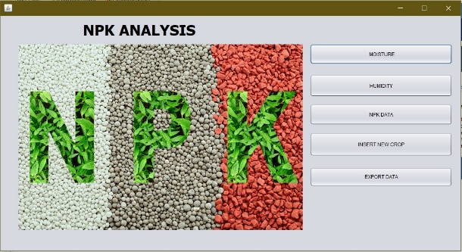

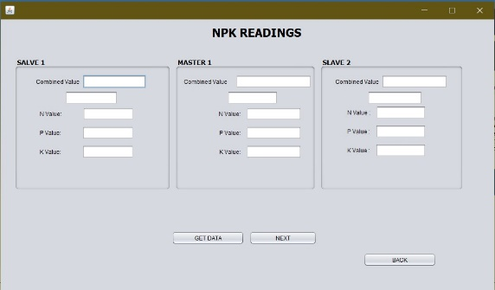

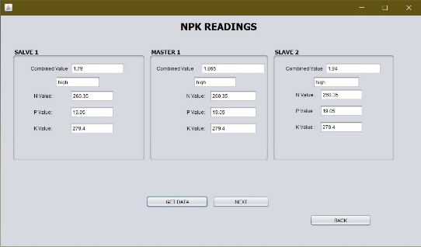

|  |  |
| --- | --- |
| Topic Name: | Smart Farming(NPK) App |
| Representative Task | Insert New Crop |
| KLM Model Analysis | **M** – To decide to select the Insert New Crop option in menu and think of steps required to do it  **H** – Switch hand from keyboard to mouse  **P** - Move the mouse pointer to Insert New Cropoption  **BB** – Click Insert New Crop option and release hand from mouse.  **M** – To decide to select Get Data  **P** – Move the mouse pointer to Insert New Crop**.**  **BB –** Click on Insert New Cropand release the hand from mouse. |
| Final KLM | **MHPBBMPBB** |
| Execution Time | **4.7 seconds** |

**Snapshots:**

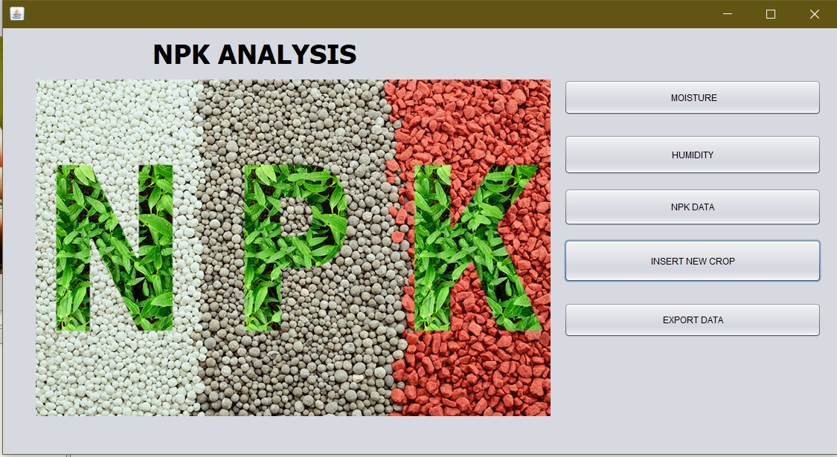

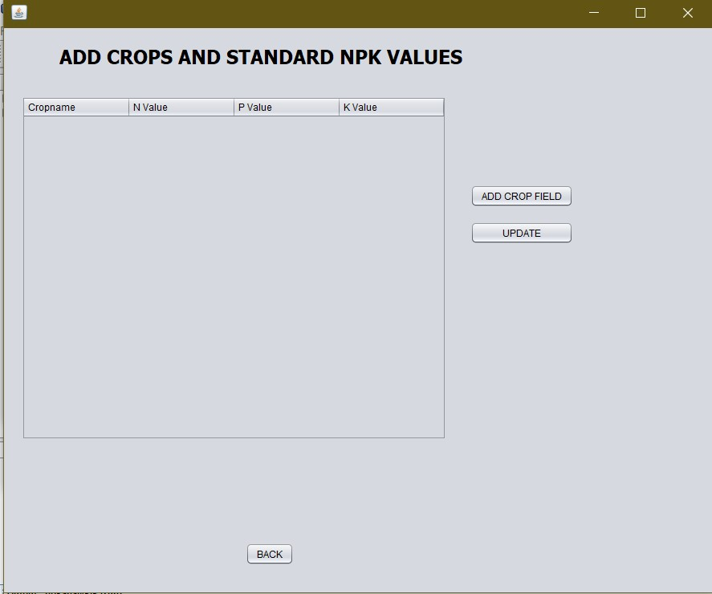

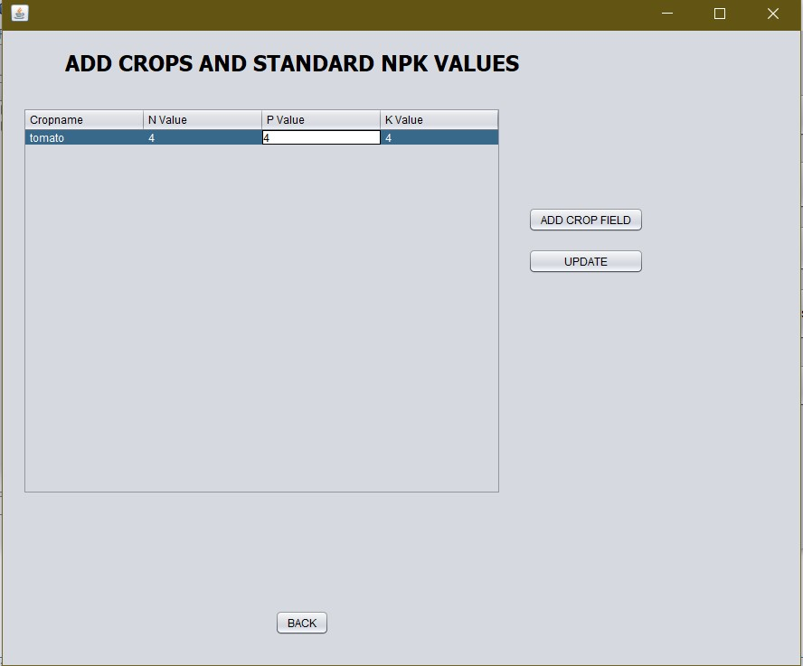

1. **GOMS Model**

|  |  |
| --- | --- |
| Topic Name: | **Smart Farming (NPK) App** |
| Representative Task | **Get Moisture Data** |
| GOMS Model Analysis | **GOAL:** Select **Moisture** option(Use menu-based method)  **Operator:** Switch hand from keyboard to mouse  **Operator:** Move the mouse pointer to **Moisture** option  **Operator:** Click on **Moisture** option  **Operator:** Move the mouse pointer to **update** option  **Operator:** Click mouse button to get Moisture data  **Goal:** Shortcut method  **Operator:** Press Tab button to get Moisture data  **Operator:** Again press Tab button to update moisture data |

**Snapshots:**

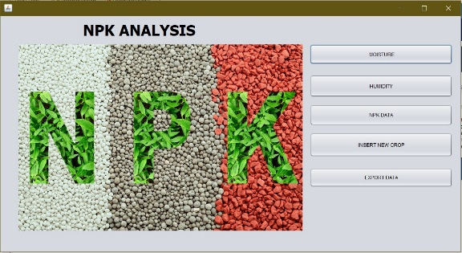

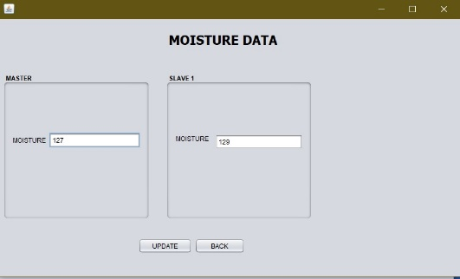

|  |  |
| --- | --- |
| Topic Name: | **Smart Farming (NPK) App** |
| Representative Task | **Humidity Data** |
| GOMS Model Analysis | **GOAL:** Select Humidity Data option(Use menu-based method)  **Operator:** Switch hand from keyboard to mouse  **Operator:** Move the mouse pointer to Humidity Dataoption  **Operator:** Click on Humidity Dataoption  **Operator:** Move the mouse pointer to **update** option  **Operator:** Click mouse button to get Moisture data  **Goal:** Shortcut method  **Operator:** Press Tab button to get Moisture data  **Operator:** Again press Tab button to update moisture data |

**Snapshots:**

